INTRODUCTION
- The aim is to provide a brief guide to operating as a safety boat driver for the Staunton Harold Sailability Trust (SHST)
- The first part of the document deals with the responsibilities of the driver and boat usage.
- The second part deals with the people issues you may encounter.
- The third part deals with operational procedures to be carried out by safety boat drivers.

PART 1: SAFETY BOAT DRIVER RESPONSIBILITIES AND BOAT USAGE
- Safety boat drivers work under the direction of the person in charge of the session (The session Lead).
- They should be qualified to RYA Powerboat Level 2 and ideally hold a Safety Boat certificate, or under direct instruction, registered as an approved driver by the trust for insurance purposes.
- A crew should always accompany the driver whenever a RIB goes to afloat and should be dressed to enter the water if necessary.
- Drivers should be familiar with the contents of the SHST Safety Boat Guide, which should be read annually at least. And a signed confirmation provided
- All drivers must check that the boat is fully prepared and ready for service before leaving the shore.
- They should then return it in this condition on completion of the duty and report any issues regarding the safety of the boat and equipment to the Bosun (in person or via the board in the boathouse).
- They should be aware that the order of priority during a rescue are:
- Their own and RIB crew’s personal safety
- The safety of other boat crews
- The rescue or prevention of damage to other vessels or equipment.
- The control of a specific rescue is in the hands of the RIB Driver. If casualties fail to comply with instructions, the RIB Driver may leave the rescue after a clear warning.
- If RIB Drivers consider that conditions are beyond what they feel able to deal with safely, they must inform the person in charge.
- During an event, the RIB Driver should stay on station until stood down by the person in charge.
- Radio communication must be established between the land based person in charge and rescue teams afloat when attending an incident.
- Be aware of local hazards such as the rocks near mark no 9, slipways, fishermen on the banks, dogs in the water etc.
- The boat should never be left unattended by the jetty with the engine running and the key must be removed to prevent unauthorised use so long as there is another safety boat on the water.
- Before engaging reverse gear, ensure that there is plenty of time for the revs to drop.
- Ensure that the engine is lifted when entering shallow water.
- Please note that any health and safety incidents should be reported to the Club.
- Registered drivers (the record of registered drivers is held by the secretary and will be PB2 Holders) should consider allowing their crew to do some driving, if appropriate. This is one of the few feasible methods of providing practice for relatively inexperienced drivers. However, check with the session lead before doing so.

PART 2: SAILABILITY PEOPLE CONSIDERATIONS

Anyone sailing a Hansa dinghy, or a Challenger is VERY likely to have some form of disability or physically limiting condition.
- It may not be obvious what it is, is could be a hearing or sight deficiency, a lower or upper limb function or movement issue. It could be Autism or a range of other issues.
- When dealing with a situation it is very important to be calm as they could be distressed at a situation they don’t understand, do not raise your voice speak in a normal tone. Do not touch the individual without checking its ok to do so, some may also find making eye contact uncomfortable.
- You will need to explain in very simple easily understood commands (not technical they may not know the names of boat parts) what you are doing or what you are asking the person requiring assistance to do.
- If you are unsure radio ashore for help and guidance.
- Sailability participants should be returned to the shore as soon as possible after an incident before they continue sailing again.
- In any rescue its highly likely you will have to carry out most of the required actions to the boat as the sailor may not be able to do so.

PART 3: Sailability Boats
The Hansa dinghy is a non-hiking dinghy designed for disabled sailors, all controls are in the cockpit where the sailor sits. Steering is by means of a joy stick and the only other controls are a main sheet, jib sheets in double sailed boats, a furling line and an outhaul all led into the cockpit.
The rudder is non tilting and drops into a frame and the centre board is locked in place with a long pin running through the top of the centreboard and into a hole in the centre board casing and must not be removed whilst afloat. These are weighted and fill with water and are non-retractable whilst on the water.
Hansa’s cannot be sailed or towed with the centreboard in any position other than fully down as boats become unstable.
They are designed not to invert however it is a possibility, normally they would lay at capsize then right themselves however you shouldn’t wait for this to happen.
The main sail and jib can be furled by releasing the outhaul and either manually winding the mast to draw the sail in or by pulling the furling line that runs alongside the centre board casing.
Rescue:
These boats can only be landed safely at the jetty, approach the boat from windward and come alongside, ideally in any rescue situation furl the main sail or release it to blow freely in the wind, the safest and easiest recovery is to tow the boat to shore in all cases and allow the sailor time to regather and compose themselves should they wish to continue sailing. If the sailor is able to get out of the dinghy into the rescue boat then they should be removed. towing can be alongside or behind in the normal manner, towing alongside is probably the best position as it allows the rescue crew to do much of the work and the close contact avoids having to issue complicated instructions. do not lift the weighted centre board.
If a Hansa runs aground then gently tow them back out into deeper water , its unlikely that it will take anything more than a gentle movement back into deeper water if you cannot do this then you need to evacuate the sailor to recover the boat you must not lift the keel with anyone in the boat.

figure shows Hansa cockpit with centre board in on shore upright position
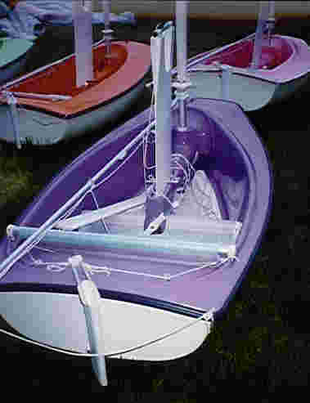

Figure shows a single Seat Hansa cockpit with centre board fully down and steering joystick in place
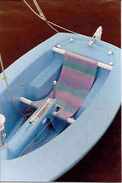

Figure Shows the cockpit of a Challenger Dinghy

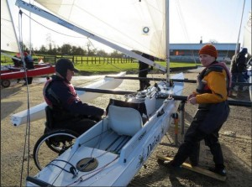

The challenger dinghy has a central hull and two floats one either side, giving it the appearance of a trimaran, it is a very stable boat because of its configuration and whilst it is possible to capsize its highly unlikely for this to happen on inland water without a significant structural failure. It has all the controls of any modern sailing dinghy with everything led to the cockpit, including the tiller which is in front of the sailor.
It has a short centre board that is lifted from within the cockpit and the rudder is raised or lowered by a two-rope system (one up one down) these are in the cockpit on either side of the helms seat. The floats are strong enough to stand on and use as an access route to the cockpit if required. These should be approached to bring the rescue boat alongside one of the floats (ideally windward as this allows you to better control the boat direction) alternatively the bow of rib can drive slowly between the hull and the float giving the crew easy access to the helm of the challenger.
Figure shows Challenger under sail
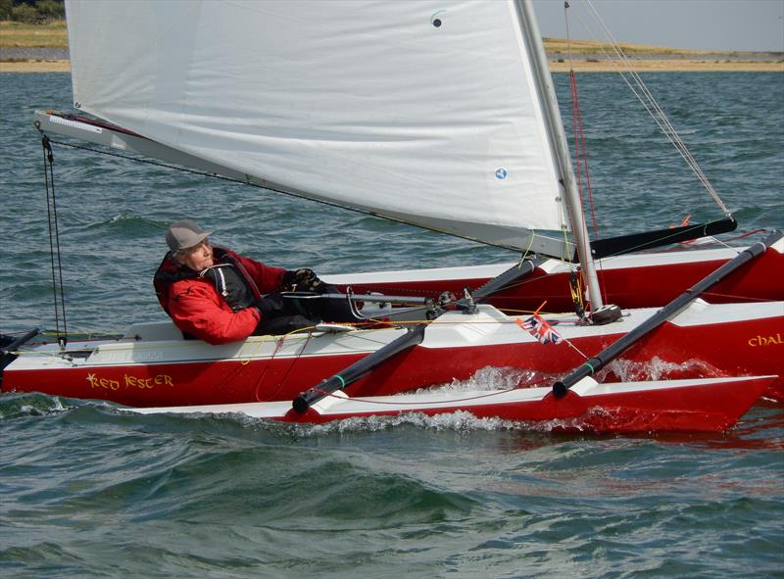
Taking a challenger to shore is most easily achieved by towing behind the safety boat, it is recommended that you beach the challenger and recover boat and helm from an onshore position pulling boat and helm out onto dry land.

PART 3: RESCUE TECHNIQUES
- Safety boat drivers will encounter a range of problems which will require diverse solutions depending upon the specific situation and the prevailing conditions.
- Safety boat drivers must always maintain clear communication with their crew, who should act as an observer and respond to the drivers’ instructions.
- Safety boat drivers should also continually assess the potential risks of all situations taking account of weather, water state, lea shore and other hazards.
- Using a RIB on a lea shores should be undertaken with great care.
- The safety boat should be equipped with throwing lines which may assist the recovery of individuals in the water and possibly in boats.
- In any situation, the driver’s safety priorities are listed in the following order of importance:
  - The safety of the driver and crew
  - The safety of anyone else (e.g. person being rescued)
  - The prevention of damage to boats and equipment
- In a rescue situation, people involved must follow the safety boat driver’s instructions if they are to retain the support of the safety boat.
- In the event that a safety boat driver assesses a rescue situation as potentially hazardous to another boat , themselves and crew, they must instruct the people to leave their craft and enter the safety boat.
- Should they fail to comply, the safety boat should stand-off at a safe distance.
Key points of approaching, standing off, and coming alongside another boat
- Be aware of objects and people in the water.
- Position strategically up wind, aft and close enough for clear communication. There should be no chance of drifting or being swept by waves into contact with a boat or casualty. The position should be such that it is reasonably easy to manoeuvre, without delay in forward gear alone, alongside the boat should this be required.
- Watch personnel and be prepared to kill the engine should anyone drop into the water close to the propeller and aft of the consul.
- Communicate with all regarding engine state (e.g. engine in neutral, going forward, reversing).
- Manoeuvre precisely and efficiently taking account of the water state, wind and other conditions prevailing.
- Approach windward side. If recovering a boat from capsize approach from the windward side to avoid the boat coming over on you on righting.
- Ensure that there are no ropes or other objects which can get wrapped around the prop.

Retrieving people from the water
- Approach from downwind.
- Communicate with casualty.
- Crew at bow calls for contact.
- Stop at casualty without having to use reverse.
- Cut engine immediately upon contact unless it’s not safe to do so.
- To assist a casualty into the RIB, the helm and crew should work together.
- Method 1: Ask the casualty if they can be held first then with the person facing you, take hold of a hand and top of the arm each, and pull him/her up into the boat.
- This may be done on a count of three with a dunk first, then pull. The casualty could face away from the boat, but care needs to be taken to avoid spinal problems.
- Radioing ashore before being casualty in!

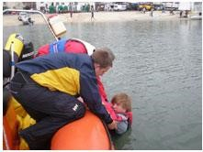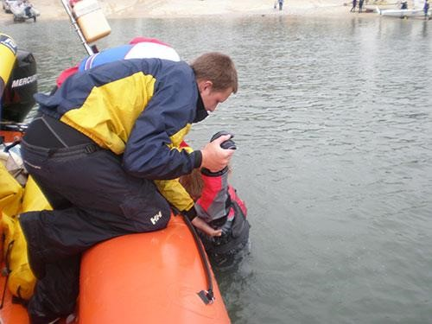

Forward Facing Method. Backward Facing Method.
- Method 2: with the casualty facing the RIB with an arm over the tube, instruct them to raise their knee.
- Reach down and lift the knee onto the tube.
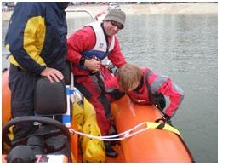
- Then crew and helm help person to slide/roll into the boat.
- A sponson tube can be deflated in extreme conditions.
- Method 3: The person can enter from the transom by using the anti-cavitation plate as a step. The hydraulic engine lift can also be used to raise them higher.
- Be careful in bumpy water as there is a risk of injury and possibly bending the hydraulic steering gear.
- Method 4: Use a rope secured at both ends and
dangling in the water as a foot hold for the person to step up and helped by the crew and helm to get into the boat.
- Ideally a hand hold is also needed and, if nothing else is suitable, a short length of line secured to the inside of the boat may be required.
- It is best to attempt this towards the back end of the boat where the tubes are lower.
- Method 5: a webbing/strop type ladder, clipped onto the seat frame with a carbine hook. There is a thick piece of webbing attached which forms a foot hold and the upper section forms a hand hold.
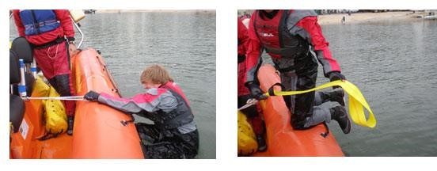

Retrieving damaged boats
- If a vessel cannot be driven/sailed, it should either be anchored temporarily until it can be later retrieved or alternatively towed back into the shore.
- If anchored, a spare anchor and warp would need to be carried in the safety boat.
- The boat should also be marked to signify that the boat has been attended to and nobody is trapped or missing.
- If a boat is to be towed, line tows are the quickest and easiest method.
- The line should be attached securely near to the front of the towed vessel .
- The line can be attached at a single point towards the back of the RIB (e.g. on an eye-bolt or at the bottom of the rear metal hoop).
- Ideally it should be attached at the centre of a bridle connected to two points across the back of the RIB.
- A side tow may be used for smaller vessels.
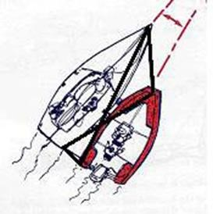

- This requires the rear of the towed vessel to be forward of the RIBs engine.
- It also requires both vessels to be tied securely together with front and rear ropes and crossing springs, which takes some time to prepare.

